**MICROPROCESSOR BASED SYSTEM DESIGN**

**TASK 1**



**Spring 2021**

**CSE307 MBSD**

Submitted by: **Shah Raza**

Registration No. : **18PWCSE1658**

Class Section: **B**

“On my honor, as student of University of Engineering and Technology, I have neither given nor received unauthorized assistance on this academic work.”

Student Signature: ______________

Submitted to:

**Dr. Bilal Habib**

Sunday, April 18th, 2021

**Department of Computer Systems Engineering**

**University of Engineering and Technology, Peshawar**

## Task # 01:

* Create a delay of 10msec.
* Turn ON an LED for 4msec and then turn OFF for 6msec. Do it continuously.

### Problem Analysis:

### We will start by setting the pin 1 of port 1 that means the LED at pin 1 will get turned ON, after that we will call the delay subroutine. Inside delay are two nested loops:

* Inner Loop: 2 nop(s)[1 machine cycle each] and 1 djnz[2 machine cycles] instruction.
* Upper loop: 1 djnz instruction.

If we run the inner loop 250 times then it will take 250(1(nop)+1(nop)+2(djnz)) = 1000usec and by running the upper loop 4 times we get 4*1000 = 4000usec = 4msec.

So we have successfully created a delay of 4msec. Now we will check the pin 1 of port 1, if the pin 1 was set(1) we will return from delay function if not then we will create a 2msec extra delay meaning a 4+2=6msec delay in case the LED was OFF.

### Code:

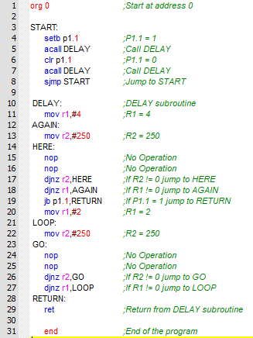

### Output / Graphs / Plots / Results:

**Circuit Diagram:**

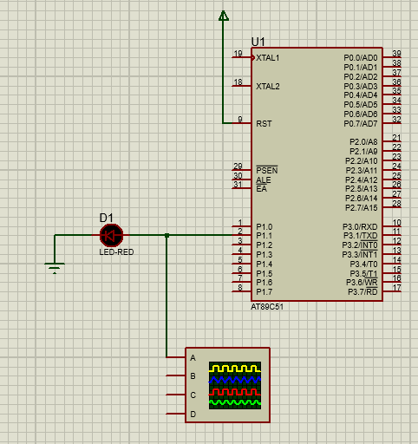

### .

**Oscilloscope Verification:**

